

RFC 0114 - Payment and Billing for Vehicle Device
Confidential, Draft
27 Pages

Abstract

Document Information

Table of Contents
0 Document Information 2
0.1 Table of Contents 2
0.2 Terminology and Document Conventions 4
0.3 Revision History 4
1 Introduction 4
2 Application Domain 4
2.1 Payment and Billing domain for Vehicle Device 4
2.2 Entities 5
3 Problem Description 5
4 Requirements 6
4.1 High Level Functional Requirements 6
4.2 Overall System Requirements 7
4.3 System Elements 7
4.3.1 Telematics Terminal 7
4.3.2 Telematics Server 7
5 Technical Solution 8
5.1 Overview 8
5.2 Sequence Chart 8
5.2.1 Charging per service 8
5.2.2 Charging information notification 10
5.2.3 Charging information notification 11
5.3 Class Diagram 12
6 Java API 12
6.1 Class PaymentService 12
6.1.1 PaymentService 14
6.1.2 main 14
6.1.3 createSession 14
6.1.4 getBillInformation 14
6.1.5 demandService 14
6.1.6 cancel 15
6.1.7 confirm 15
6.1.8 getPaymentHistory 15
6.1.9 terminateSession 16
6.2 Class Bill 16
6.2.1 serviceId 17
6.2.2 serviceName 17
6.2.3 serviceDescription 17
6.2.4 serviceProvider 17
6.2.5 serviceFee 17
6.2.6 Bill 17
6.2.7 toString 17
6.3 Class CreditCard 18
6.3.1 cardNumber 19
6.3.2 cardholder 19
6.3.3 expirationYear 19
6.3.4 expirationMonth 19
6.3.5 paymentMethod 19
6.3.6 CreditCard 19
6.3.7 toString 19
6.4 Class Payment 20
6.4.1 NOT_SPECIFIED 21
6.4.2 INSTANTLY 21
6.4.3 MONTHLY 21
6.4.4 chargedDate 22
6.4.5 serviceId 22
6.4.6 serviceName 22
6.4.7 serviceDescription 22
6.4.8 serviceProvider 22
6.4.9 serviceFee 22
6.4.10 lastFourDigitsOfCreditCardNumber 22
6.4.11 paymentType 22
6.4.12 Payment 22
6.4.13 equals 23
6.4.14 toString 23
6.5 Class AuthenticationException 23
6.5.1 AuthenticationException 24
6.6 Class DeclineException 24
6.6.1 DeclineException 25
7 Considered Alternatives 25
8 Security Considerations 25
9 Document Support 25
9.1 References 25
9.2 Author’s Address 26
9.3 Acronyms and Abbreviations 26
9.4 End of Document 26

Terminology and Document Conventions
The key words "MUST", "MUST NOT", "REQUIRED", "SHALL", "SHALL NOT", "SHOULD", "SHOULD NOT", "RECOMMENDED", "NOT RECOMMENDED", "MAY" and "OPTIONAL" in this document are to be interpreted as described in [1].
Source code is shown in this typeface.

Revision History
The last named individual in this history is currently responsible for this document.

Revision | Date | Comments
Initial  R1.1 | 2006.01.16 | Document Creation
R1.2 | 2006.03.04 | Chapter 7 Considered Alternatives are written by considering the comments issued in Sophia-Antipolis meeting(Jan. 19)

Introduction
To be able to charge a user for the use of an OSGi Telematics service, it is vital to have a common method for payment and billing. This document describes the requirements for a standardized and secure interface for payment and billing between a Telematics Terminal and a Telematics Server

Application Domain

Payment and Billing domain for Vehicle Device

A standard charging model with a common interface for payment and billing are needed to apply commercial business model to telematics services.

The OMA MCC (Mobile Commerce and Charging) proposes an on-line charging and off-line charging model. The charging model and operations in this document correspond mainly with the on-line charging model of the OMA.

The charging model may include the following information;

- User authentication information
- Charging Information (as defined in OMA MCC)
  - Charging method
  - Payment amount
  - Payment date
  - Product name
  - Product ID
  - Client Information
  - Shop information
  - Etc.

Above information should be delivered to the Telematics Terminal from the Telematics Server, so payment and billing system can use the information in the Telematics Terminal.

Entities

Telematics Terminal
A Telematics Terminal is a terminal device in vehicle which is used to the telematics service.
It can be also a mobile phone or PDA.
Telematics Server
The Telematics Server is a Telematics Server system which provides various telematics services.
The User
The User is a driver or a fellow passenger in vehicle who uses the telematics service.
The Administrator
The Administrator is a telematics system Administrator in the Telematics Server side.
DMB
Digital Multimedia Broadcasting

Problem Description
Payment and billing in the telematics service will typicaly be used to provide paid services (on-line content ) to be delivered by the wireless communication network.
In this case, there are some problems to be considered as follows:

- Several Users may use several TSP’s services which have different payment and billing mechanism. The Telematics Terminal should have many interfaces for the payment and billing per TSP’s services.
- As the number of services and contents increase, the corresponding payment and billing policies may be added as well.
- The telematics Users require the transparent and consistent payment and billing method regardless of the specific service.

Therefore, a standardized payment and billing interface between the terminal and the Telematics Server is needed.

The on-line contents and services are as follows;

- Application download
- VOD service
- Ticketing service
- GOD(Game on Demand) service
- MOD(Music on Demand) service
- DMB service
- On-line shopping
- Reservation for auto-repair service

Through the standardized payment and billing interface, the application developer and the contents provider can concentrate more on the developing services.
In the TSP’s aspect, adapting the standardized interface, they can provide the contents and services efficiently and import other TSP’s services and contents more easily.

Requirements

High Level Functional Requirements
- The payment and billing system in the Telematics Terminal must be independent of the payment method.
- The balance of the account must not be revealed without the User’s permission.
- Charging should be done per service
- It should be possible for the User to set limits for accumulated charges or volume of transferred data, especially in charging of a streaming service, e.g. VOD service.
- Billing information should be notified to the User before the payment is made.
- The User or the service Administrator shall be able to browse the User’s payment history.
- A standardized interface between Telematics Terminal and Telematics Server is required to manage payment and billing service. => SyncML of OMA can be applicable, but it needs to be checked whether the real time transaction requirements can be guaranteed.
- The payment and billing system should provide the balance of his pre-paid or post-paid accounts to the User

Overall System Requirements
- The User must be authorized to use the service which he has to pay for.
- The service should be authorized by the TSP.
- The service channel must be secure.

System Elements

Telematics Terminal
- The Telematics Terminal must provide billing information of the service. The information should be transferred by the Telematics Server.
- The Telematics Terminal must provide confirm methods to check the service charge.
- The Telematics Terminal may have an interface to get the credit card information.
- The Telematics Terminal must provide the result of success or failure of the payment.
- The Telematics Terminal should provide the User’s payment history information.

Telematics Server
- The Telematics Server must have billing information and authorisation information of the service.
- Before the service which user has to pay is invoked, the Telematics Server should transfer the billing information of the service to the Telematics Terminal.
- The Telematics Server should have a method to check the User’s credit.
- The Telematics Server must have a rollback mechanism when the payment is aborted.
- The Telematics Server must respond to the Telematics Terminal about the result of the payment immediately.
- The Telematics Server should provide the User’s payment history for the Telematics Server Administrator.

Technical Solution

Overview
The basic architecture of payment and billing for Vehicle Device is exchanging the User authentication information and the charging information between the Telematics Terminal and the Telematics Server.
The Telematics Server waits for requests to come in over the network. It performs certain operations like an authentication and getting billing information based on that request, and then possibly returns a result to the Telematics Terminal.
The User can get the information of the service which she/he is interested in, and purchase those services. For getting the service information, the user don't need to login. However, the user is required to login in order to purchase services. While authenticating, a session is established. Session is essential to maintain the state of the transaction. In a session, the user can demand a service at a time. Then the payment and billing server sends a billing information for the service the User chose. Then, the User makes sure of the received billing information is correct and cancel or confirm the order she/he made.

Sequence Chart

Charging per service
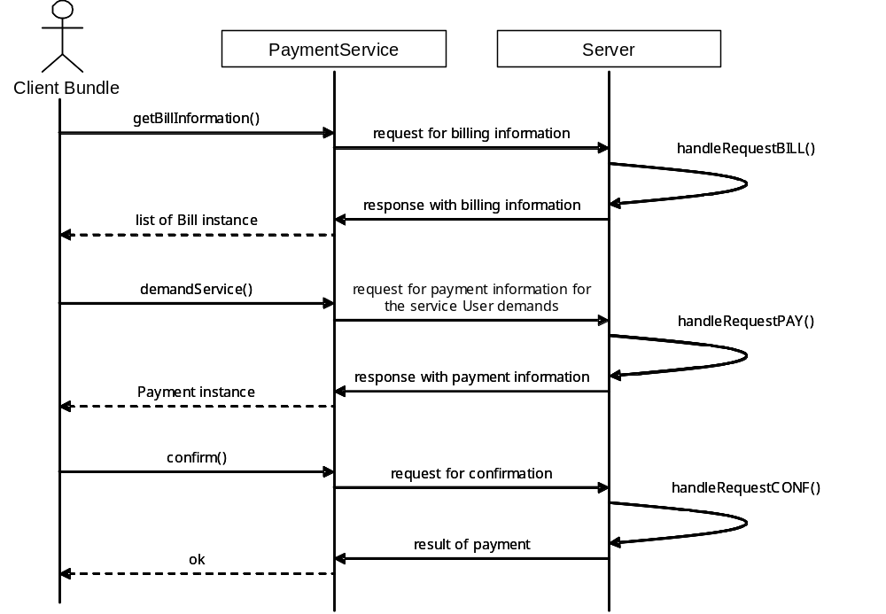

Figure1. Charging per service
- The Bill class may contain the service fee, name, provider and description, etc.
- The Payment class may contain the service id, charge date and the billing information including the Bill class has.

The client bundle calls the PaymentService’s getBillInformation() method to get a billing information per service.
The PaymentService requests to the Payment Server for the billing information and the Payment Server responds with the billing information list (list of the Bill instances).
(handleRequestBill(): The Payment Server makes a billing information of the services)
The User selects the service and proceeds to pay, the client bundle calls the PaymentService’s demandService() method
The PaymentService requests to the Payment Server for the payment information about the service user demands, and the Payment Server responds with the payment information (the Payment instance).
(handleRequestPay(): The Payment Server check the user’s credit information or the balance of the user’s account)
The User confirm to pay, the client bundle calls the PaymentService’s confirm() method
The PaymentService requests to the Payment Server for the confirmation.

Charging information notification
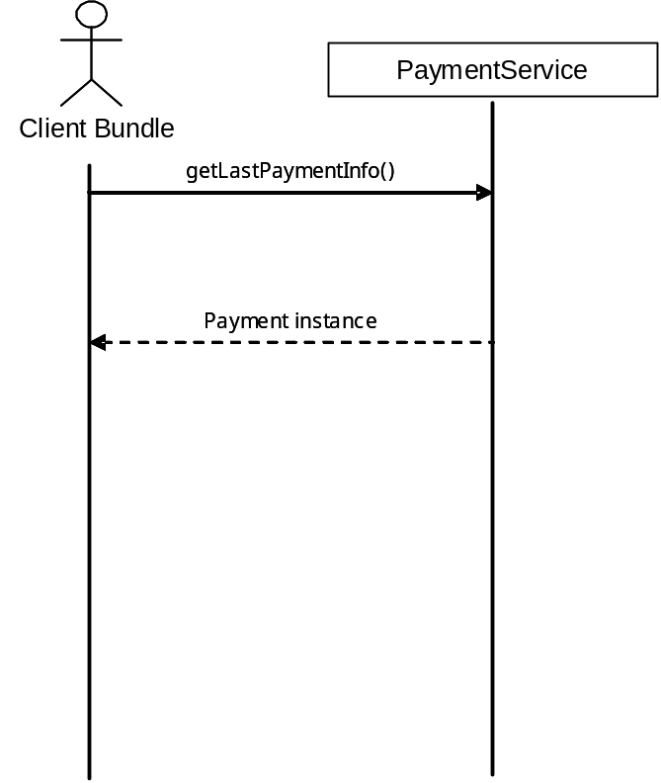

Figure2. Charging information notification

- The Payment class may contain the service id, charge date and the billing information including the Bill class has.

After the payment is done, the user should be informed the payment status (result of the payment and the payment information).
The client bundle calls the PaymentService’s getLastPaymentInfo() method to get a charging information of the offered service.
The client bundle can show the payment information of the last offered service to the user.

Charging history management
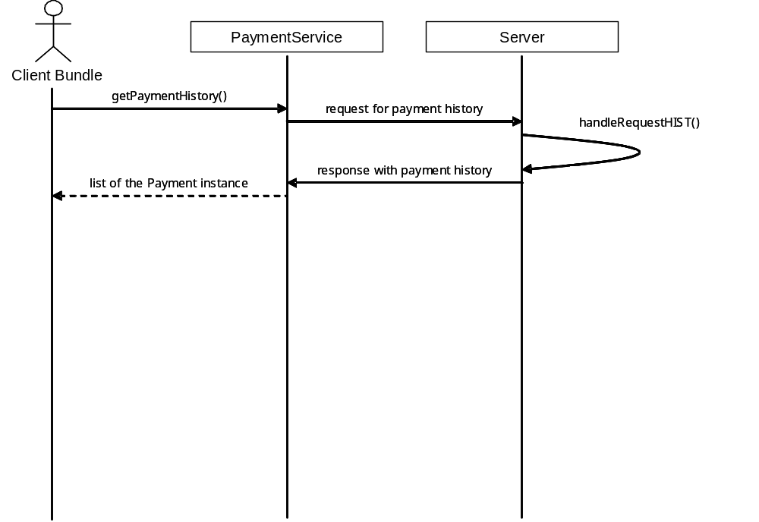

Figure3. Charging history management

- The Payment class may contain the service id, charge date and the billing information including the Bill class has.

The client bundle calls the PaymentService’s getPaymentHistory() method to get a charging history information.
The PaymentService requests to the Payment Server for the charging history information list.

Class Diagram
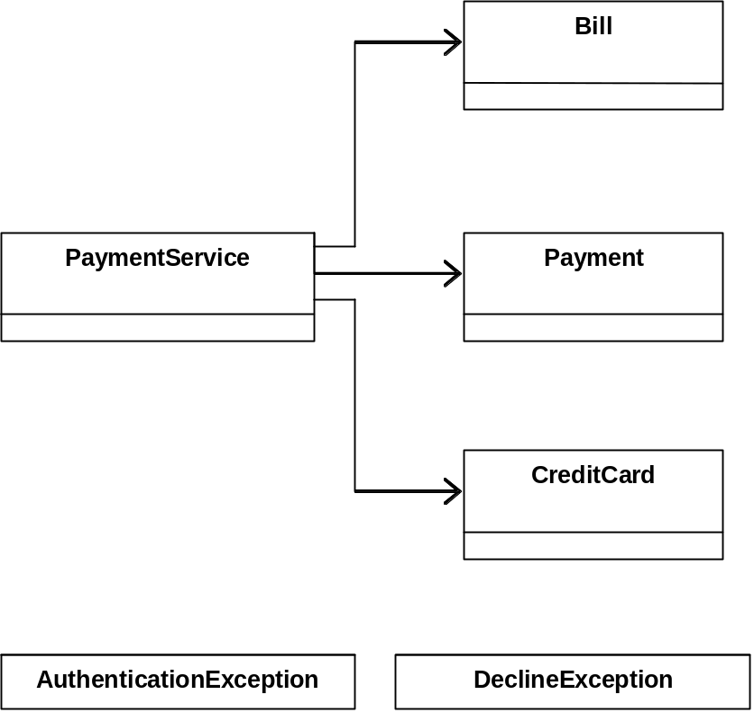

Figure4. Charging per service

Java API

Class PaymentService

public class PaymentService
extends java.lang.Object
This class implements payment and billing Telematics client. A Telematics user can get the information of the service which she/hs is interested in, and purchase those services. For getting the service information, the user don't need to login. However, the user is required to login in order to purchase services. While authenticating, a session is established. Session is essential to maintain the state of the transaction. In a session, the user can demand a service at a time. Then the payment and billing server sends a billing information for the service the user chose. Then, the user makes sure of the received billing information is correct and cancel or confirm the order she/he made. This is developed for a draft of a reference implementation so it is not appropriate to apply actual commercial scenarios. Later, more secure communication channel like SSL should be used, and for more realistic use cases, more practical protocol model should be applied.

Constructor Summary
PaymentService()

Method Summary
boolean | cancel(Payment payment)  Cancels the order made previously.
boolean | confirm(Payment payment)  Confirms the order made previously.
boolean | createSession(java.lang.String username, java.lang.String password)  Creates a session with a username and a password.
Payment | demandService(java.lang.String serviceId, CreditCard creditCard, int paymentType)  Demands the service with the service ID, the credit card information, and the payment type.
Bill | getBillInformation(java.lang.String servicetId)  Gets a billing information from the payment and billing server.
Payment[] | getPaymentHistory()  Gets the history of the payments the session user made so far.
static void | main(java.lang.String[] arg)  The main method for testing and debugging.
boolean | terminateSession()  Terminates the established session.

Methods inherited from class java.lang.Object
clone, equals, finalize, getClass, hashCode, notify, notifyAll, toString, wait, wait, wait

Constructor Detail

PaymentService
public PaymentService()
Method Detail

main
public static void main(java.lang.String[] arg)
The main method for testing and debugging.

createSession
public boolean createSession(java.lang.String username,
java.lang.String password)
throws java.io.IOException
Creates a session with a username and a password.
Parameters:
username - a username to login
password - a password to login
Returns:
true if a session creation succeeds; false otherwise.
Throws:
java.io.IOException - IO error when creating a session.

getBillInformation
public Bill getBillInformation(java.lang.String servicetId)
throws java.io.IOException
Gets a billing information from the payment and billing server.
Parameters:
servicetId - the service ID in question.
Returns:
the billing information for the given service ID.
Throws:
java.io.IOException - IO error when getting a billing information.

demandService
public Payment demandService(java.lang.String serviceId,
CreditCard creditCard,
int paymentType)
throws java.io.IOException
Demands the service with the service ID, the credit card information, and the payment type.
Parameters:
serviceId - the service ID of the demanded serive.
creditCard - the information of the credit card on which the service fee is charged.
paymentType - the payment type either instantly or monthly.
Returns:
the payment information.
Throws:
java.io.IOException - IO error when demanding the service.

cancel
public boolean cancel(Payment payment)
throws java.io.IOException
Cancels the order made previously.
Parameters:
payment - the payment information received when the service is demanded.
Returns:
true if the cancelation is processed correctly; false otherwise.
Throws:
java.io.IOException - IO error when canceling the order.

confirm
public boolean confirm(Payment payment)
throws java.io.IOException
Confirms the order made previously.
Parameters:
payment - the payment information received when the service is demanded.
Returns:
true if the confirmation is processed correctly; false otherwise.
Throws:
java.io.IOException - IO error when confirming the order.

getPaymentHistory
public Payment[] getPaymentHistory()
throws java.io.IOException
Gets the history of the payments the session user made so far.
Returns:
the set of the payments.
Throws:
java.io.IOException - IO error when getting the payment history.

terminateSession
public boolean terminateSession()
throws java.io.IOException
Terminates the established session.
Returns:
true if the session terminates successfully; false otherwise.
Throws:
java.io.IOException - IO error when terminating the session.

Class Bill
java.lang.Object
vehicle.pb.common.Bill
All Implemented Interfaces:
java.io.Serializable

public class Bill
extends java.lang.Object
implements java.io.Serializable
This class is for the billing information. The billing information is sent to the Telematics PaymentService when it is requested by a Telematics user. It contains the information of the service that the user chooses, such as service ID, service name, service description, service provider, and service fee. Since it implements Serializable, the instance of the class can be transferred in the form of stream.
See Also:
Serialized Form

Field Summary
java.lang.String | serviceDescription  The service description of the billing information.
long | serviceFee  The service fee of the billing information.
java.lang.String | serviceId  The service ID of the billing information.
java.lang.String | serviceName  The service name of the billing information.
java.lang.String | serviceProvider  The service provider of the billing information.

Constructor Summary
Bill(java.lang.String serviceId, java.lang.String serviceName, java.lang.String serviceDescription, java.lang.String serviceProvider, long serviceFee)
creates a Bill which has the billing information of the service a user chooses.

Method Summary
java.lang.String | toString()  Returns a string representation of this Bill.

Methods inherited from class java.lang.Object
clone, equals, finalize, getClass, hashCode, notify, notifyAll, wait, wait, wait

Field Detail

serviceId
public java.lang.String serviceId
The service ID of the billing information.

serviceName
public java.lang.String serviceName
The service name of the billing information.

serviceDescription
public java.lang.String serviceDescription
The service description of the billing information.

serviceProvider
public java.lang.String serviceProvider
The service provider of the billing information.

serviceFee
public long serviceFee
The service fee of the billing information.
Constructor Detail

Bill
public Bill(java.lang.String serviceId,
java.lang.String serviceName,
java.lang.String serviceDescription,
java.lang.String serviceProvider,
long serviceFee)
creates a Bill which has the billing information of the service a user chooses. The given service ID should be unique among other service IDs.
Method Detail

toString
public java.lang.String toString()
Returns a string representation of this Bill. It is used for debugging. It can be removed when Payment and Billing APIs are completed.
Overrides:
toString in class java.lang.Object
Returns:
the string representation of this Bill.

Class CreditCard
java.lang.Object
vehicle.pb.common.CreditCard
All Implemented Interfaces:
java.io.Serializable

public class CreditCard
extends java.lang.Object
implements java.io.Serializable
This class is for the credit card information. The credit card information is provided to a payment and billing server by a Telematics user to make a payment for the service that she/he wants. It contains the information of the user's credit card information, such as credit card number, cardholder's name which is shown on the card, expiration date, and payment method. Since it implements Serializable, the instance of the class can be transferred in the form of stream.
See Also:
Serialized Form

Field Summary
java.lang.String | cardholder  The cardholder's name of the credit card information.
java.lang.String | cardNumber  The card number of the credit card information.
java.lang.String | expirationMonth  The expiration month of the credit card information.
java.lang.String | expirationYear  The expiration year of the credit card information.
java.lang.String | paymentMethod  The payment method of the credit card information.

Constructor Summary
CreditCard(java.lang.String cardNumber, java.lang.String cardholder, java.lang.String expirationYear, java.lang.String expirationMonth, java.lang.String paymentMethod)
creates a CreditCard which has the credit card information a user provides.

Method Summary
java.lang.String | toString()  Returns a string representation of this CreditCard.

Methods inherited from class java.lang.Object
clone, equals, finalize, getClass, hashCode, notify, notifyAll, wait, wait, wait

Field Detail

cardNumber
public java.lang.String cardNumber
The card number of the credit card information.

cardholder
public java.lang.String cardholder
The cardholder's name of the credit card information.

expirationYear
public java.lang.String expirationYear
The expiration year of the credit card information.

expirationMonth
public java.lang.String expirationMonth
The expiration month of the credit card information.

paymentMethod
public java.lang.String paymentMethod
The payment method of the credit card information.
Constructor Detail

CreditCard
public CreditCard(java.lang.String cardNumber,
java.lang.String cardholder,
java.lang.String expirationYear,
java.lang.String expirationMonth,
java.lang.String paymentMethod)
creates a CreditCard which has the credit card information a user provides.
Method Detail

toString
public java.lang.String toString()
Returns a string representation of this CreditCard. It is used for debugging. It can be removed when Payment and Billing APIs are completed.
Overrides:
toString in class java.lang.Object
Returns:
the string representation of this CreditCard.

Class Payment
java.lang.Object
vehicle.pb.common.Payment
All Implemented Interfaces:
java.io.Serializable

public class Payment
extends java.lang.Object
implements java.io.Serializable
This class is for the payment information. The payment information is created on a payment and billing server when a user makes a payment for a service, saved on the server-side for the later use, and sent to the user for the proof of the purphase. The set of the payment information of a user is sent to a user on the user's request. It contains the information of the payment that the user has made, such as the date on which the fee has been charged, the information of the service that the user chose, the last four digits of credit card number and payment type (instantly or monthly). Since it implements Serializable, the instance of the class can be transferred in the form of stream.
See Also:
Serialized Form

Field Summary
java.util.Calendar | chargedDate  The date on which the fee is charged for the provided service.
static int | INSTANTLY  The payment type in which the whole service fee is charged instantly when the user confirms.
java.lang.String | lastFourDigitsOfCreditCardNumber  The last four digits of the credit card number on which the service fee is charged.
static int | MONTHLY  The payment type in which the service fee is charged in monthly installment.
static int | NOT_SPECIFIED  The payment type which is used when the type has not been yet specified.
int | paymentType  The payment type.
java.lang.String | serviceDescription  The service description of the paid service.
long | serviceFee  The service fee charged.
java.lang.String | serviceId  The service ID of the paid service.
java.lang.String | serviceName  The service name of the paid service.
java.lang.String | serviceProvider  The service provider of the paid service.

Constructor Summary
Payment(java.util.Calendar chargedDate, java.lang.String serviceId, java.lang.String serviceName, java.lang.String serviceDescrption, java.lang.String serviceProvider, long serviceFee, java.lang.String lastFourDigitsOfCreditCardNumber, int paymentType)
creates a Payment which has the payment information that a user makes.

Method Summary
boolean | equals(java.lang.Object object)  Indicates whether the given Object is "equal to" this Payment.
java.lang.String | toString()  Returns a string representation of this Payment.

Methods inherited from class java.lang.Object
clone, finalize, getClass, hashCode, notify, notifyAll, wait, wait, wait

Field Detail

NOT_SPECIFIED
public static final int NOT_SPECIFIED
The payment type which is used when the type has not been yet specified.
See Also:
Constant Field Values

INSTANTLY
public static final int INSTANTLY
The payment type in which the whole service fee is charged instantly when the user confirms.
See Also:
Constant Field Values

MONTHLY
public static final int MONTHLY
The payment type in which the service fee is charged in monthly installment.
See Also:
Constant Field Values

chargedDate
public java.util.Calendar chargedDate
The date on which the fee is charged for the provided service.

serviceId
public java.lang.String serviceId
The service ID of the paid service.

serviceName
public java.lang.String serviceName
The service name of the paid service.

serviceDescription
public java.lang.String serviceDescription
The service description of the paid service.

serviceProvider
public java.lang.String serviceProvider
The service provider of the paid service.

serviceFee
public long serviceFee
The service fee charged.

lastFourDigitsOfCreditCardNumber
public java.lang.String lastFourDigitsOfCreditCardNumber
The last four digits of the credit card number on which the service fee is charged.

paymentType
public int paymentType
The payment type.
Constructor Detail

Payment
public Payment(java.util.Calendar chargedDate,
java.lang.String serviceId,
java.lang.String serviceName,
java.lang.String serviceDescrption,
java.lang.String serviceProvider,
long serviceFee,
java.lang.String lastFourDigitsOfCreditCardNumber,
int paymentType)
creates a Payment which has the payment information that a user makes.
Method Detail

equals
public boolean equals(java.lang.Object object)
Indicates whether the given Object is "equal to" this Payment.
Overrides:
equals in class java.lang.Object
Parameters:
object - the reference object with which to compare.
Returns:
true if this Payment is the same as the argument object; false otherwise.

toString
public java.lang.String toString()
Returns a string representation of this Payment. It is used for debugging. It can be removed when Payment and Billing APIs are completed.
Overrides:
toString in class java.lang.Object
Returns:
the string representation of this Payment.

Class AuthenticationException
java.lang.Object
java.lang.Throwable
java.lang.Exception
java.lang.RuntimeException
vehicle.pb.exception.AuthenticationException
All Implemented Interfaces:
java.io.Serializable

public class AuthenticationException
extends java.lang.RuntimeException
Thrown by the Telematics terminal to indicate a failure of the authentication with given username and password.
See Also:
Serialized Form

Constructor Summary
AuthenticationException()

Method Summary

Methods inherited from class java.lang.Throwable
fillInStackTrace, getCause, getLocalizedMessage, getMessage, getStackTrace, initCause, printStackTrace, printStackTrace, printStackTrace, setStackTrace, toString

Methods inherited from class java.lang.Object
clone, equals, finalize, getClass, hashCode, notify, notifyAll, wait, wait, wait

Constructor Detail

AuthenticationException
public AuthenticationException()

Class DeclineException
java.lang.Object
java.lang.Throwable
java.lang.Exception
java.lang.RuntimeException
vehicle.pb.exception.DeclineException
All Implemented Interfaces:
java.io.Serializable

public class DeclineException
extends java.lang.RuntimeException
Thrown by the Telematics terminal to indicate a failure to make a payment because the credit card company declines the requested charge.
See Also:
Serialized Form

Constructor Summary
DeclineException()

Method Summary

Methods inherited from class java.lang.Throwable
fillInStackTrace, getCause, getLocalizedMessage, getMessage, getStackTrace, initCause, printStackTrace, printStackTrace, printStackTrace, setStackTrace, toString

Methods inherited from class java.lang.Object
clone, equals, finalize, getClass, hashCode, notify, notifyAll, wait, wait, wait

Constructor Detail

DeclineException
public DeclineException()

Considered Alternatives
This RFC has some overlap with some parts of RFC 14 (Accouting Service) as follows. However RFC14 and JSR 182 foucus only Creit card payment system, But lots of online payment system are not considered yet for example IVR(Interractive Voice Response) payment, Mobile Phone payment etc. Therefore this RFC will be revised suggesting these several payment methods additionally.

RFC114 subparts | Other RFCs
2.1 Charging per service | RFC 14 – Accounting Service  Interface org.osgi.service.accouting.AccountingService  initiateCharge()  chargeAndCommit()
2.2 Charging information notification | Interface Inteface org.osgi.service.accounting.ChargeState  AddChargeStateListener(ChargeStateListener l)  Commit()  Cancel()
2.3 Charging history management

Security Considerations

Later, more secure communication channel like SSL should be used, and for more realistic use cases, more practical protocol model should be applied.

Document Support

References
- Bradner, S., Key words for use in RFCs to Indicate Requirement Levels, RFC2119, March 1997.
- Software Requirements & Specifications. Michael Jackson. ISBN 0-201-87712-0
- M-Commerce Gap and Overlap Report, OMA MCC
- OMA-RD_BCAST-V1_0-20040825-D, OMA MCC

Author’s Address

Name | Kyong-Ho Kim
Company | ETRI, TelematicsUSN Research Division
Address | 161 Gajung-dong, Yusong-gu, Daejon, Korea
Voice | +82-42-869-1634
e-mail | kkh@etri.re.kr

Acronyms and Abbreviations

End of Document

